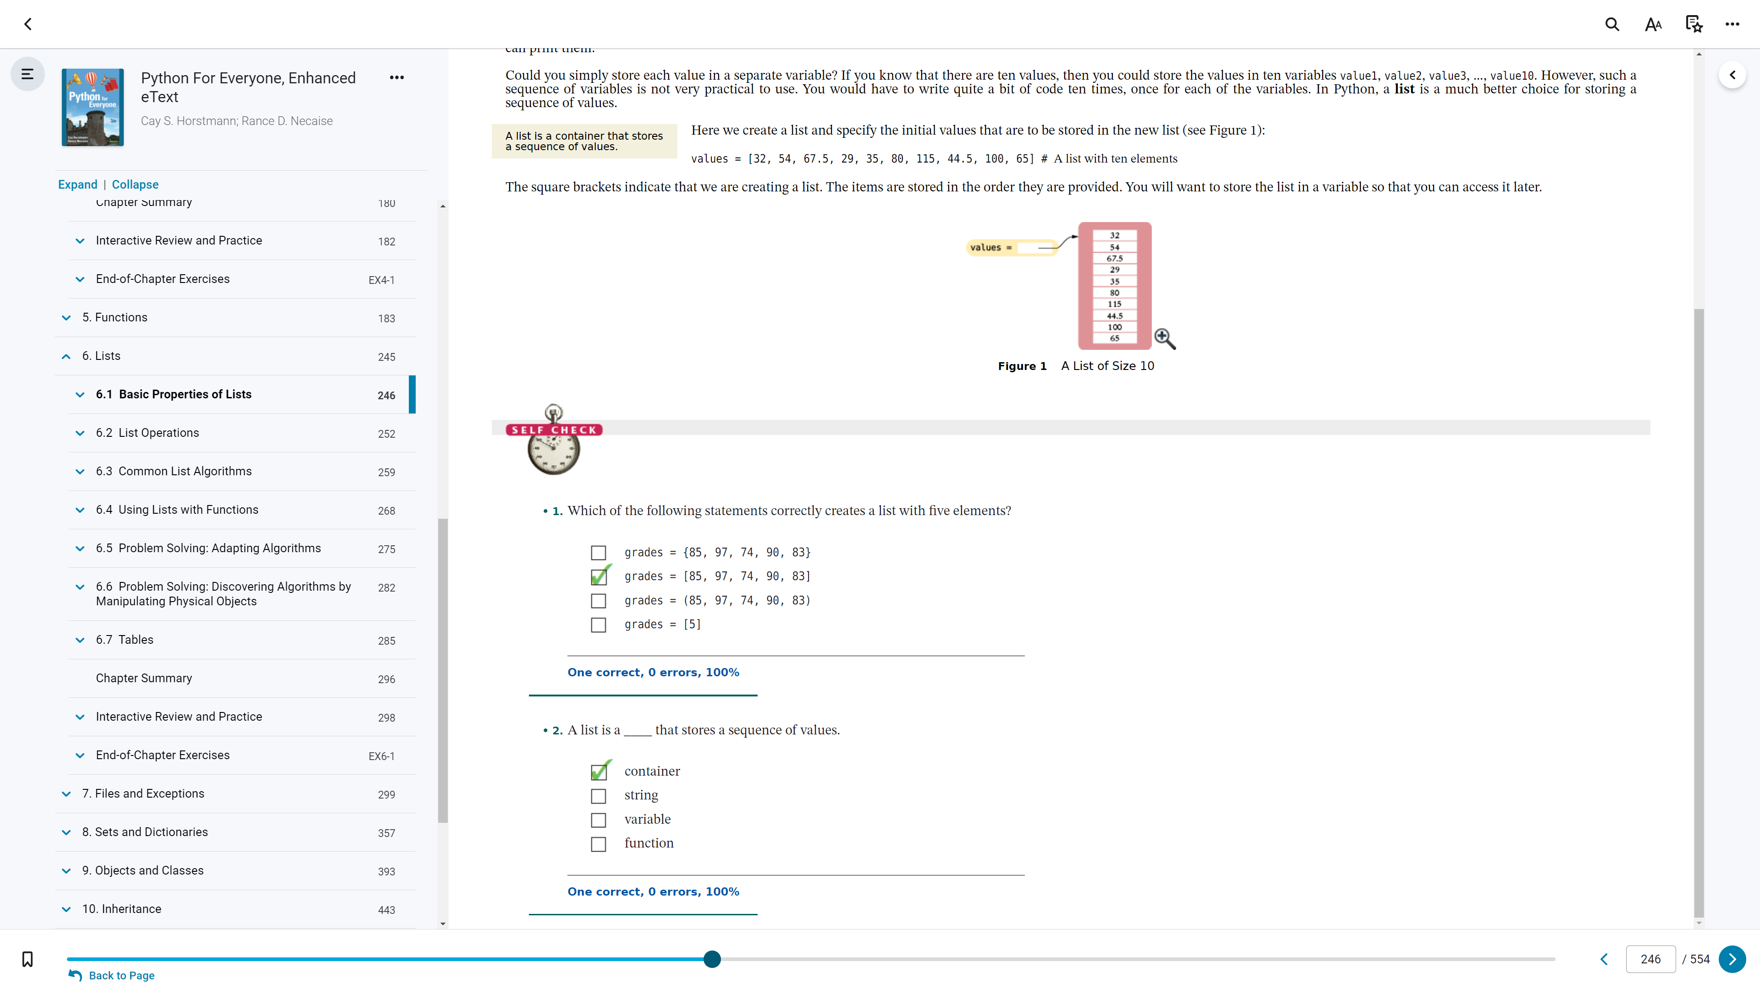

6.1

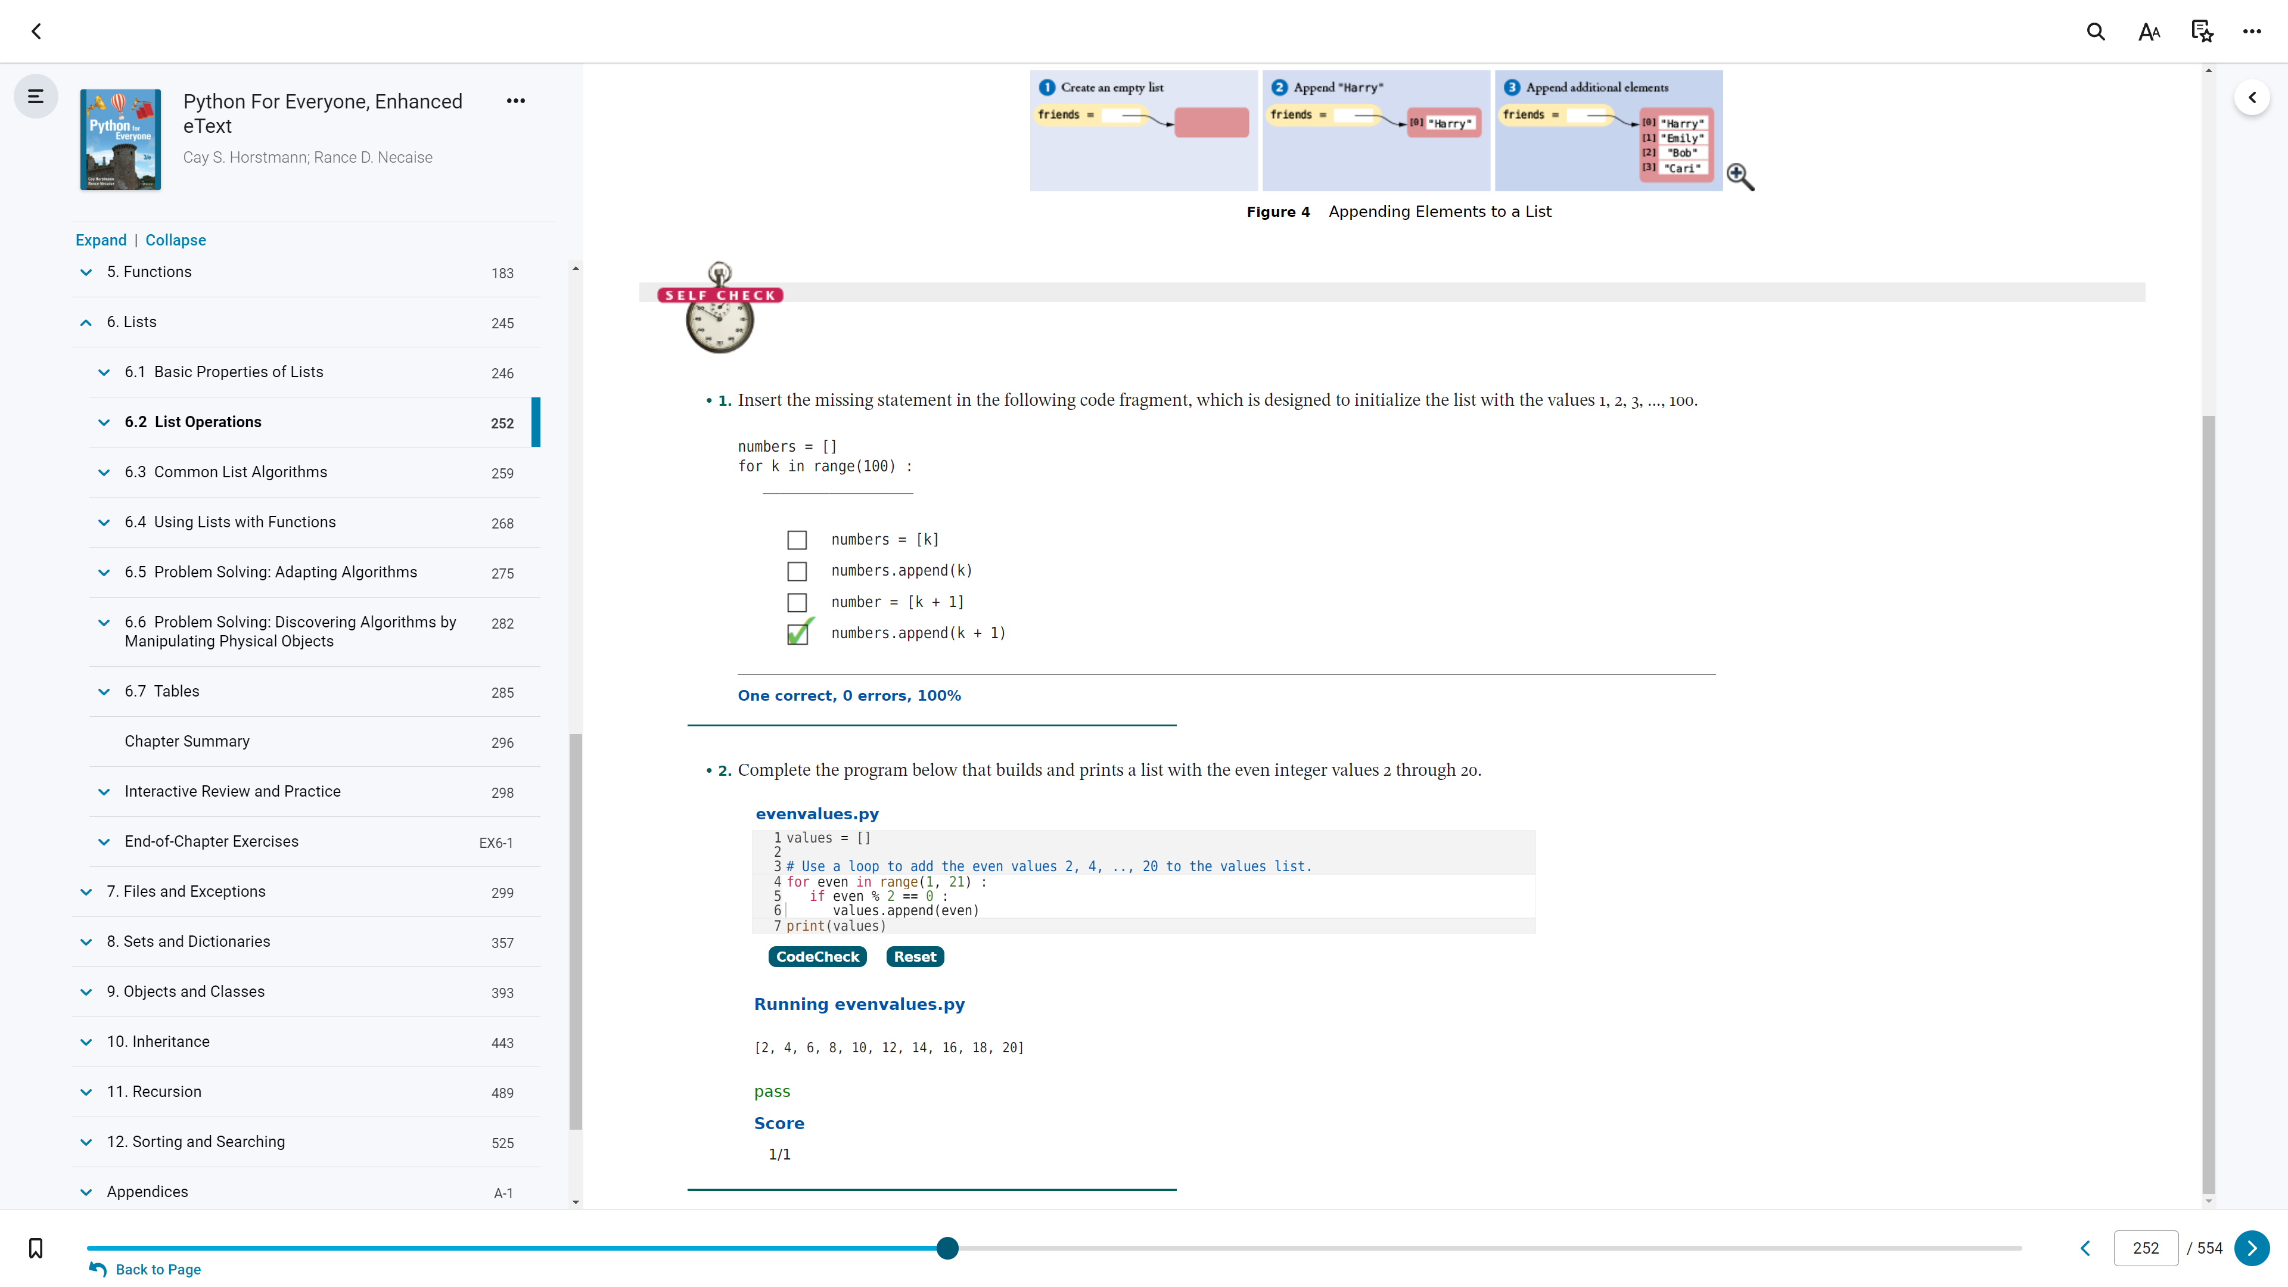

6.2

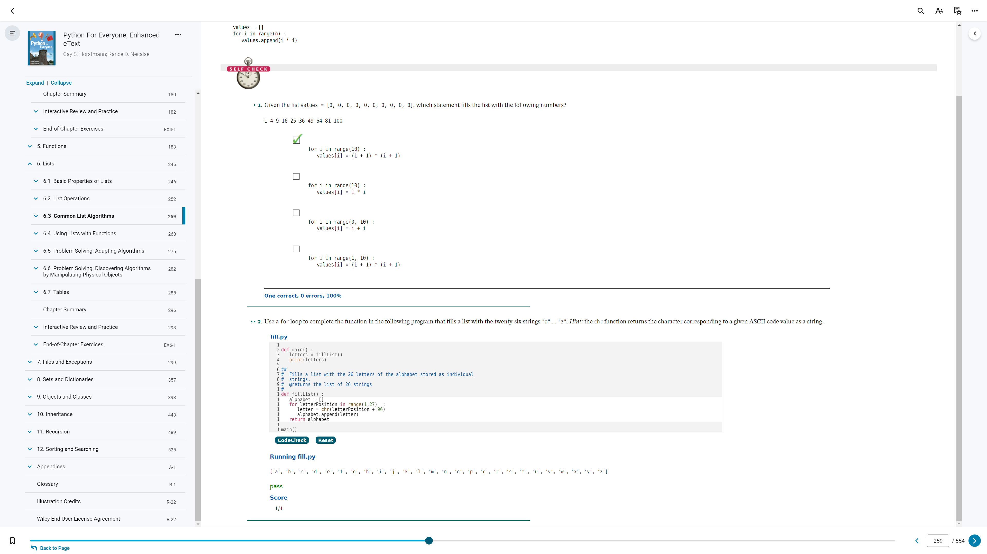

6.3

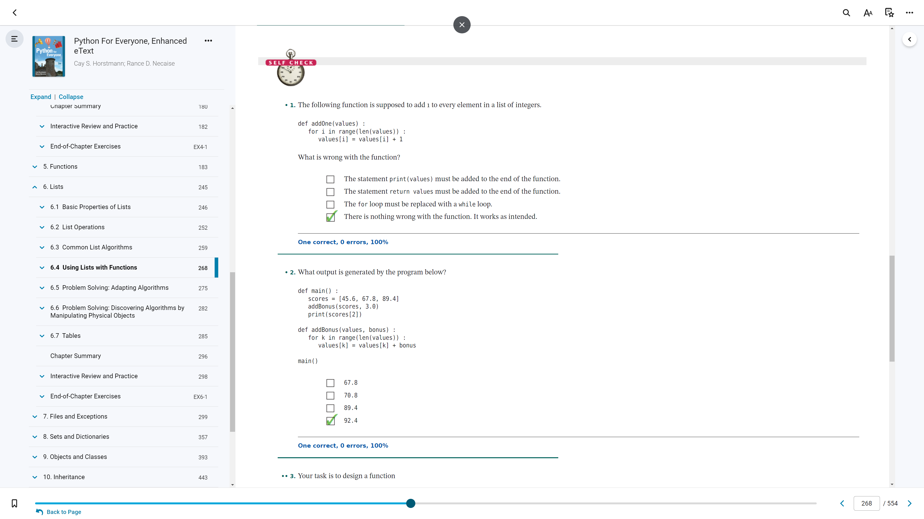

6.4 (p.1)

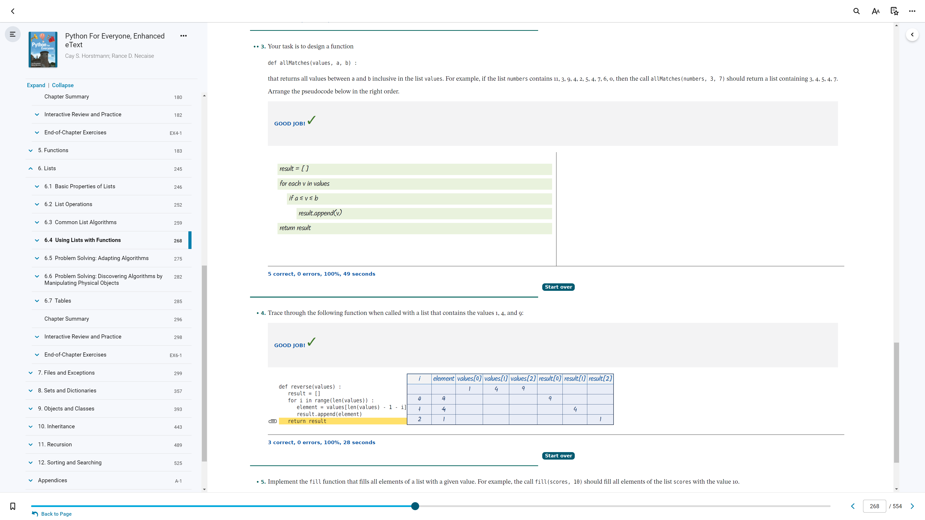

6.4 (p.2)

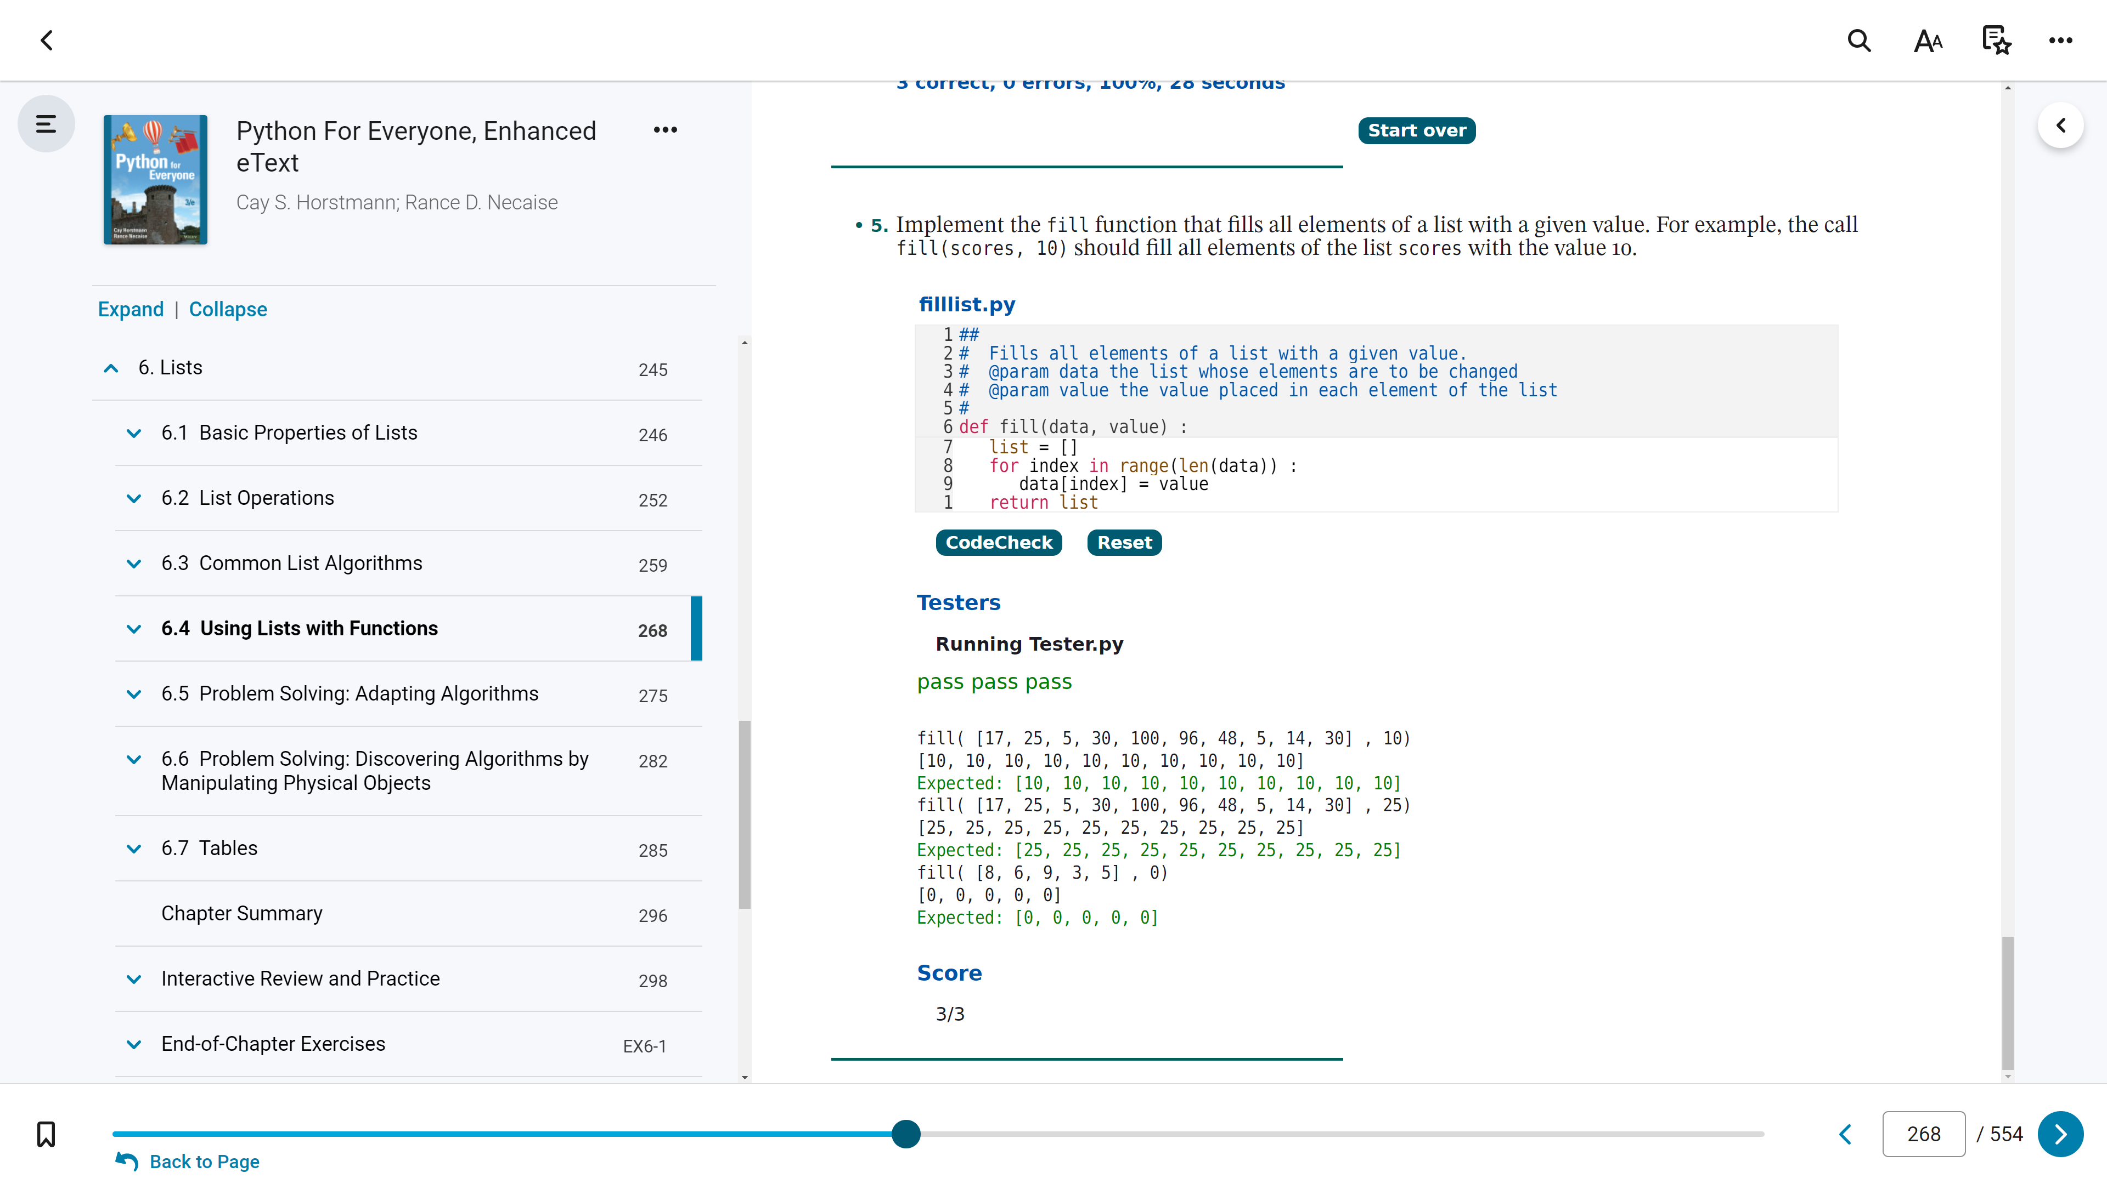

6.4 (p.3)

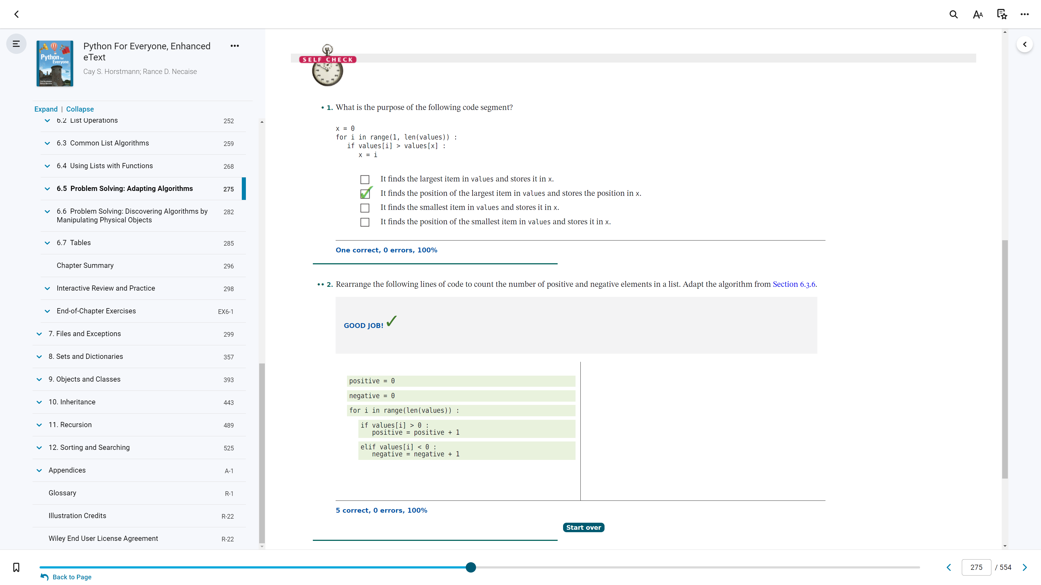

6.5 (p.1)

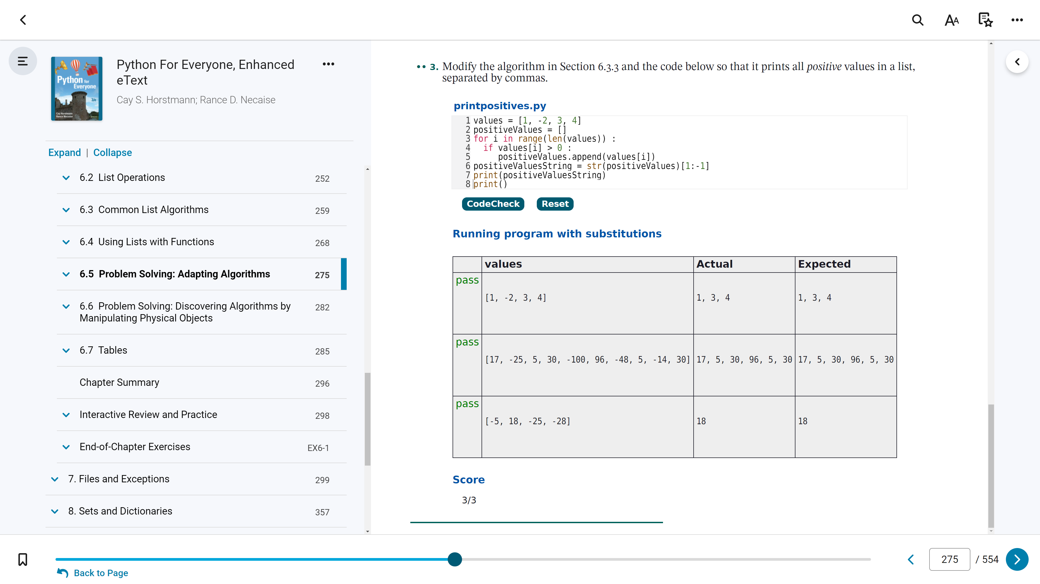

6.5 (p.2)

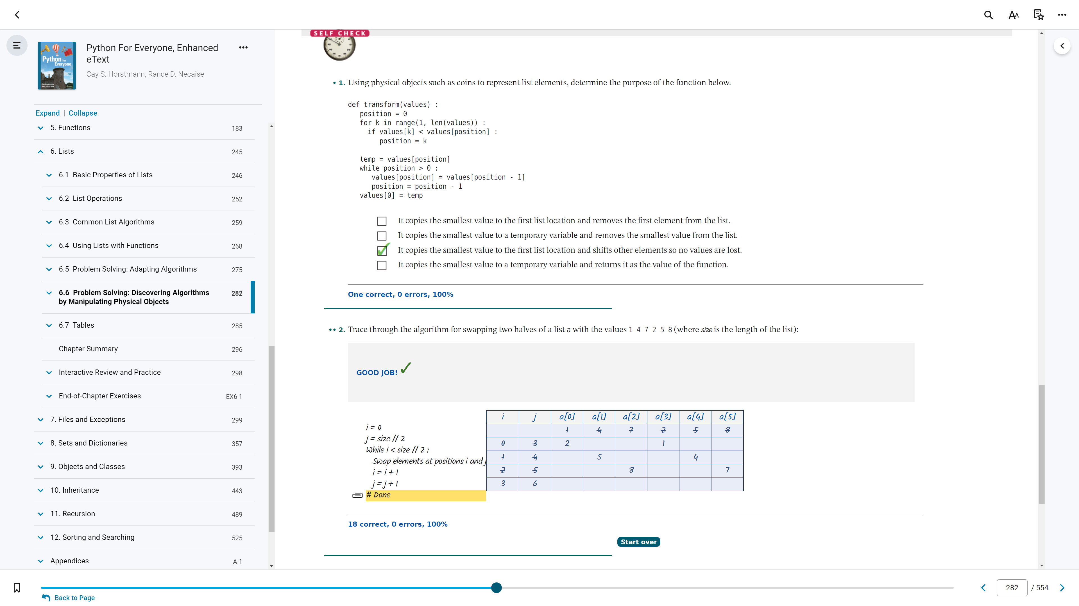

6.6 (p.1)

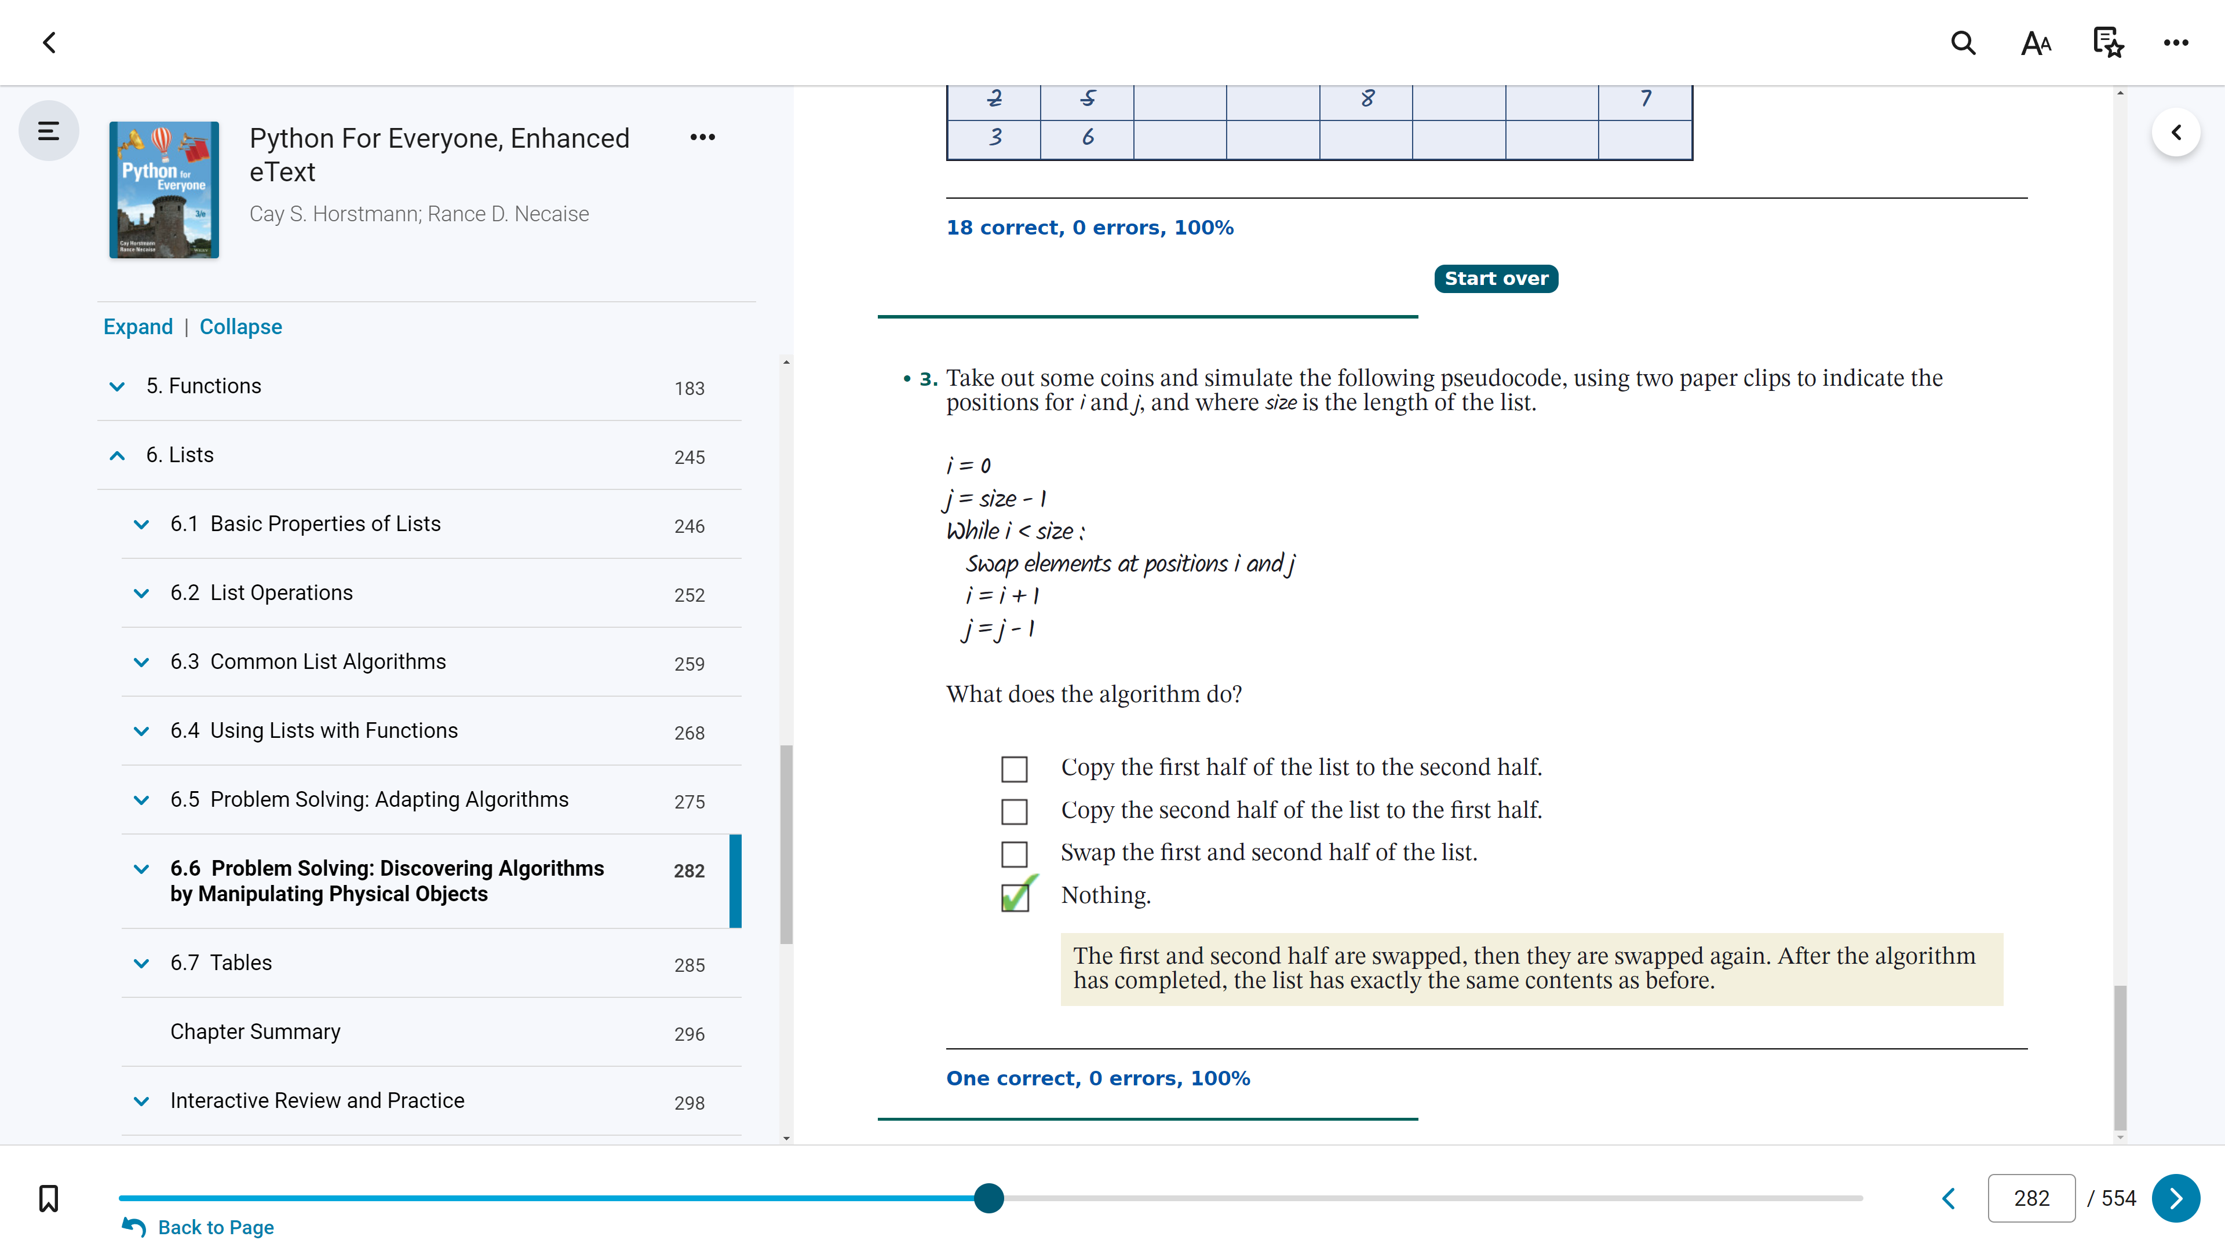

6.6 (p.2)

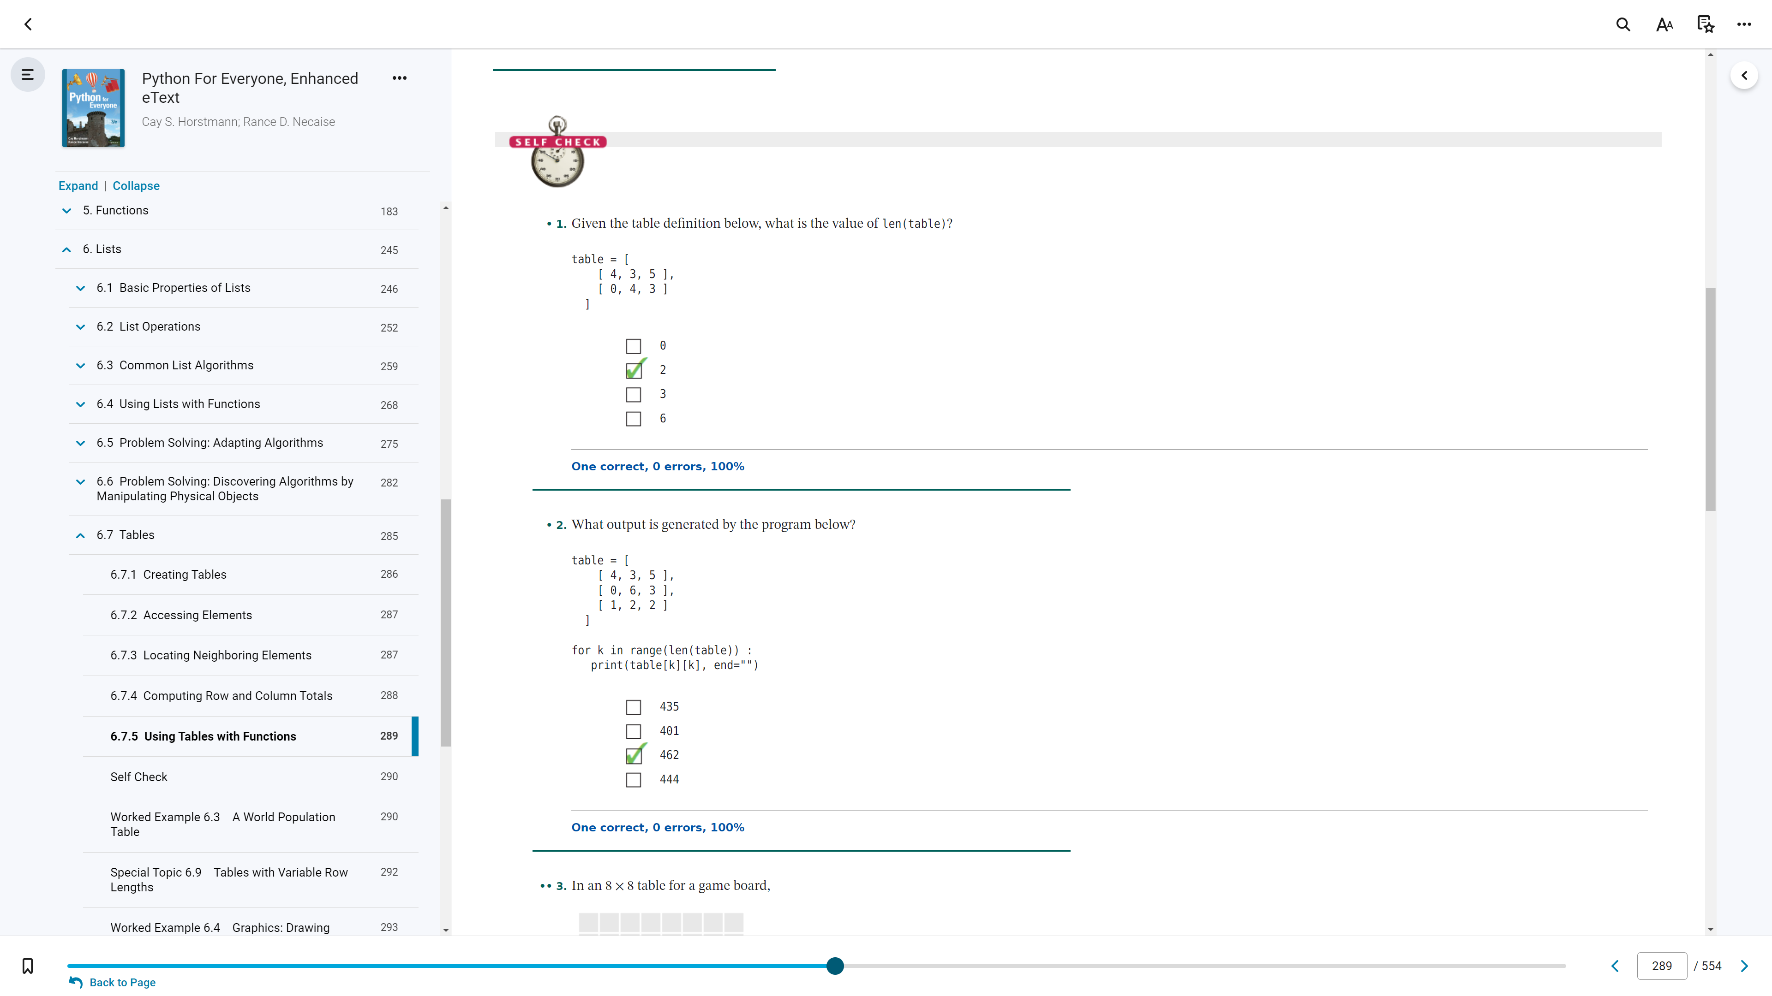

6.7 (p.1)

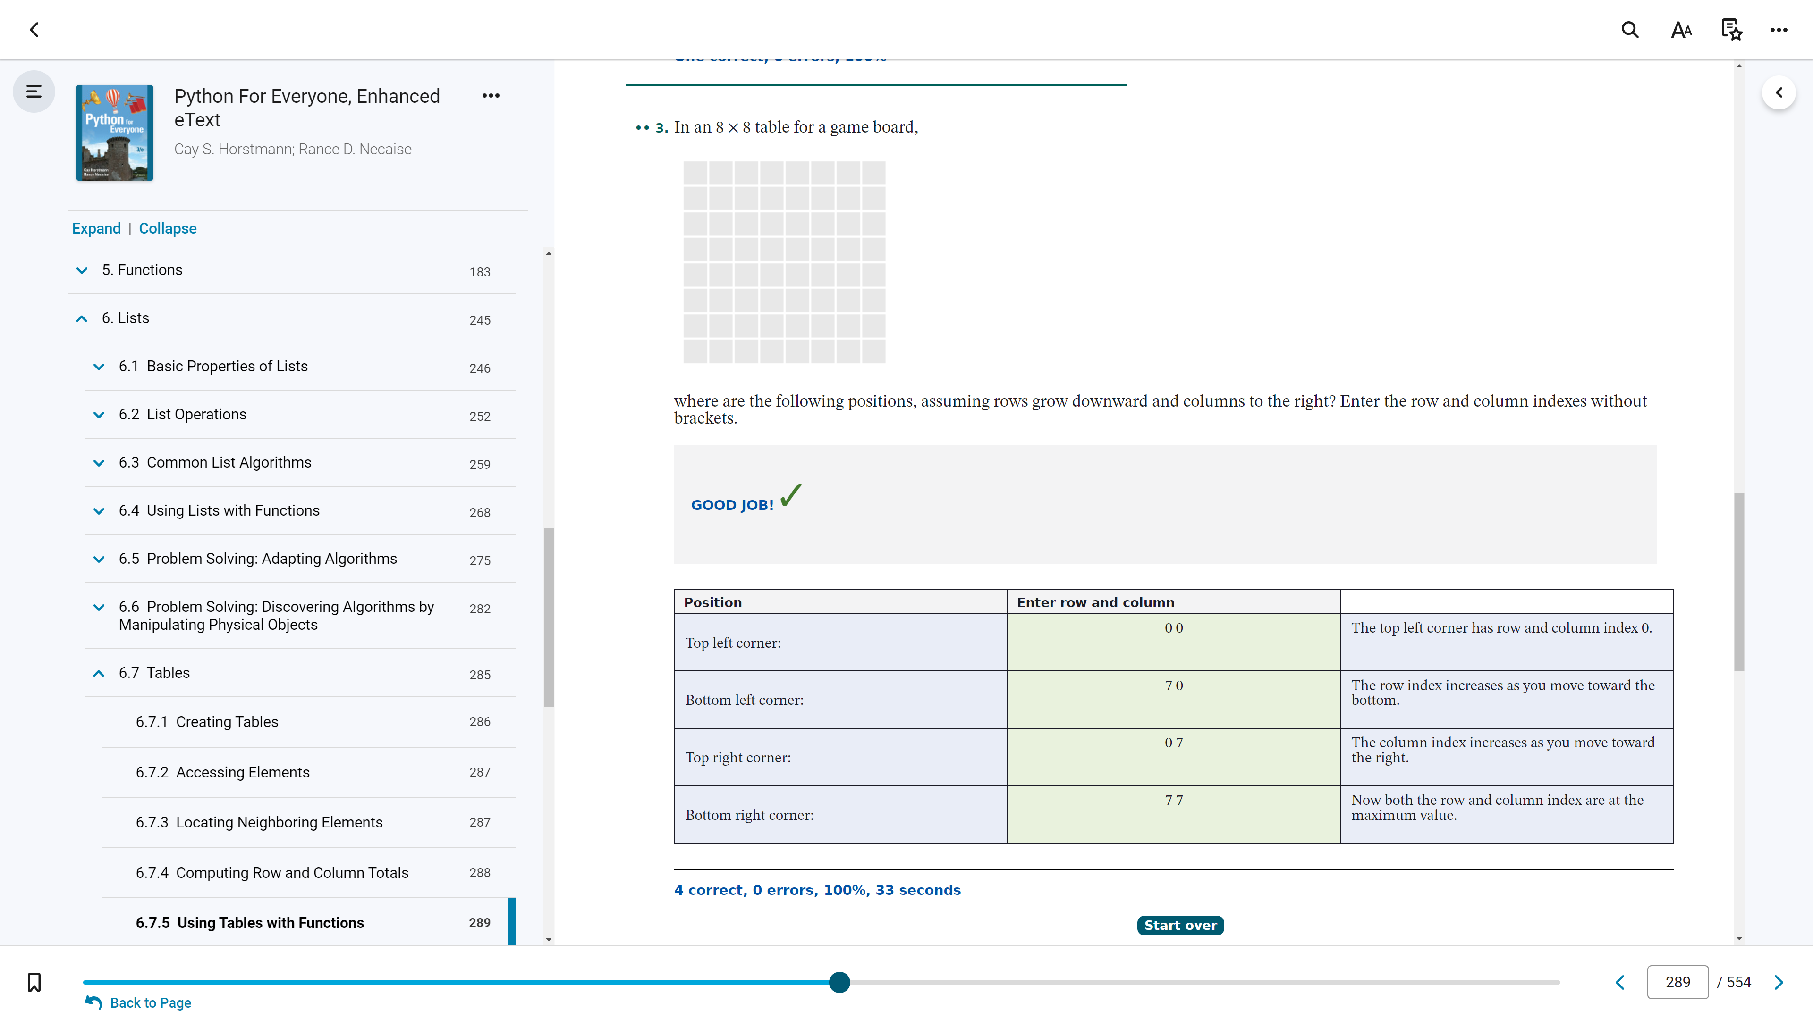

6.7 (p.2)

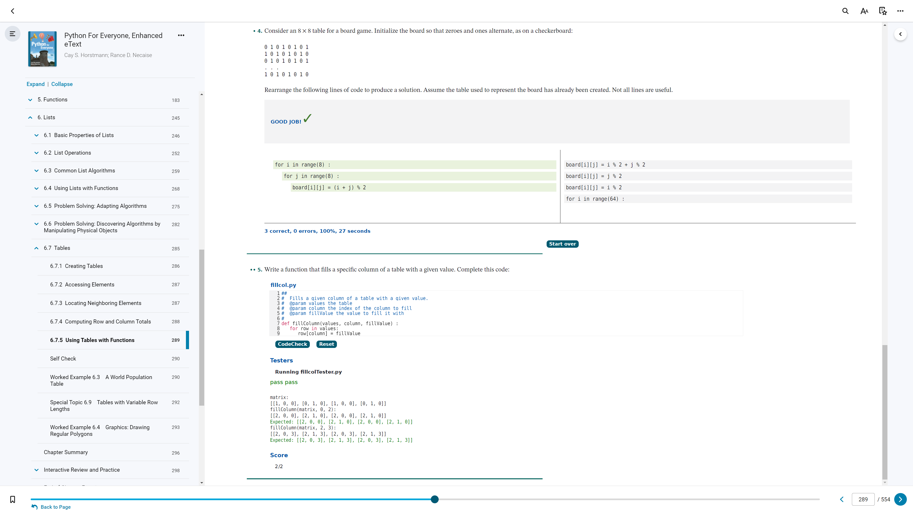

6.7 (p. 3)

6.1 - Basic Properties of Lists (1, 2)
6.2 - List Operations (1, 2)
6.3 - Common List Algorithms (1, 2)
6.4 (p.1) - Using Lists with Functions (1, 2)
6.4 (p.2) - Using Lists with Functions (3, 4)
6.4 (p.3) - Using Lists with Functions (5)
6.5 (p.1) - Problem Solving: Adapting Algorithms (1, 2)
6.5 (p.2) - Problem Solving: Adapting Algorithms (3)
6.6 (p.1) - Problem Solving: Discovering Algorithms by Manipulating Physical Objects (1, 2)
6.6 (p.2) - Problem Solving: Discovering Algorithms by Manipulating Physical Objects (3)
6.7 (p.1) - Tables (1, 2)
6.7 (p.2) - Tables (3)
6.7 (p. 3) - Tables (4, 5)

